Final Assessment - The Full Process: From IP Schemes, To Simulations and to Troubleshooting (Task 1)

Mina R.R. Ghabrial (239758130)

University of Sunderland

CETM71 - Computer Architectures And Networks

Stephen Swales

August 12, 2024

# 

# 

# 

# 

# 

# 

Table of Contents

**Task 1 - The IP schemes 3**

IPv4 Addressing Scheme 3

The Process 4

IPv4 Addressing Scheme Table 5

IPv6 Addressing Scheme 6

The Process 6

IPv6 Addressing Scheme Table 7

Explanation 8

# 

# 

# 

# 

# 

# 

# 

# 

# 

# Task 1 - The IP schemes

“For this task, take the network diagram shown below [(Image 1)] and create two IP schemes - one for IPv4 and another for IPv6. You should choose suitable IP address ranges as appropriate. You should supply a scheme table for each version, and a reworked diagram showing your IP scheme applied to the diagram.” (Swales, n.d.)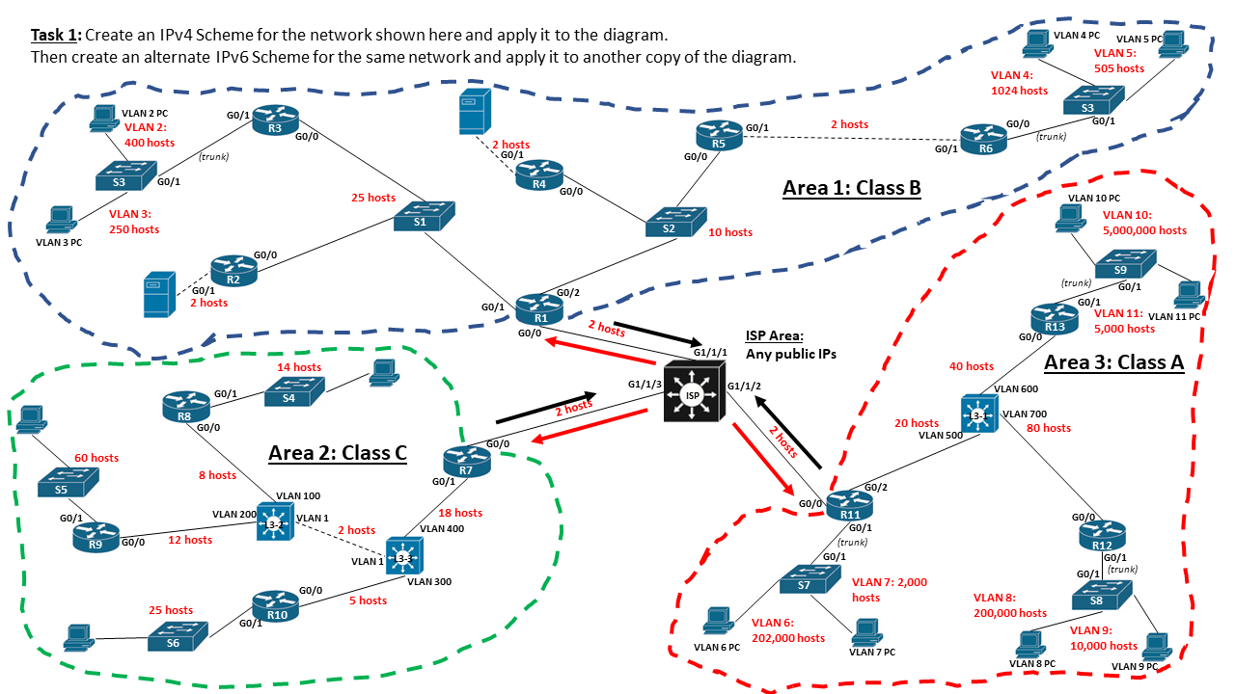

*Image 1 - the network diagram used for task 1, in a “before” state (Swales, n.d.)*

## 

## IPv4 Addressing Scheme

To effectively manage the IP allocation for the network diagram provided, I have employed Variable Length Subnet Masking (VLSM) to optimally distribute IP addresses according to the size of each VLAN. The methodology ensures each VLAN has adequate addresses while minimising wastage, crucial for maintaining network efficiency and scalability - resulting in Image 2, a few pages below.

### The Process

1. Determine the Number of Subnets and Hosts: Analyse network requirements based on host numbers provided in the diagram.
   * VLAN 2: 400 hosts
   * VLAN 3: 250 hosts
   * VLAN 4: 1024 hosts
   * VLAN 5: 505 hosts
   * VLAN 10: 5,000,000 hosts
   * VLAN 11: 5,000 hosts
   * VLAN 6: 202,000 hosts
   * VLAN 7: 2,000 hosts
   * VLAN 8: 200,000 hosts
   * VLAN 9: 10,000 hosts
2. Calculate the Subnet Mask for Each VLAN: Utilise subnetting principles to assign the smallest possible subnet for the required number of hosts in each VLAN.
   * For 400 hosts: /23 (Subnet Mask: 255.255.254.0)
   * For 250 hosts: /24 (Subnet Mask: 255.255.255.0)
   * For 1024 hosts: /22 (Subnet Mask: 255.255.252.0)
   * For 505 hosts: /23 (Subnet Mask: 255.255.254.0)
   * For 5,000,000 hosts: /9 (Subnet Mask: 255.128.0.0)
   * For 5,000 hosts: /19 (Subnet Mask: 255.255.224.0)
   * For 202,000 hosts: /13 (Subnet Mask: 255.248.0.0)
   * For 2,000 hosts: /21 (Subnet Mask: 255.255.248.0)
   * For 200,000 hosts: /13 (Subnet Mask: 255.248.0.0)
   * For 10,000 hosts: /18 (Subnet Mask: 255.255.192.0)
3. Assign Subnet Addresses: Start with the largest VLANs to allocate the subnet addresses sequentially, ensuring no overlap and efficient usage of the IP space.

### 

### IPv4 Addressing Scheme Table

| **VLAN** | **Required Hosts** | **Subnet Mask** | **Subnet Address** | **Broadcast Address** | **First Host** | **Last Host** |
| --- | --- | --- | --- | --- | --- | --- |
| VLAN 2 | 400 | 255.255.254.0 (/23) | 192.168.0.0 | 192.168.1.255 | 192.168.0.1 | 192.168.1.254 |
| VLAN 3 | 250 | 255.255.255.0 (/24) | 192.168.2.0 | 192.168.2.255 | 192.168.2.1 | 192.168.2.254 |
| VLAN 4 | 1024 | 255.255.252.0 (/22) | 192.168.4.0 | 192.168.7.255 | 192.168.4.1 | 192.168.7.254 |
| VLAN 5 | 505 | 255.255.254.0 (/23) | 192.168.8.0 | 192.168.9.255 | 192.168.8.1 | 192.168.9.254 |
| VLAN 10 | 5,000,000 | 255.128.0.0 (/9) | 10.0.0.0 | 10.127.255.255 | 10.0.0.1 | 10.127.255.254 |
| VLAN 11 | 5,000 | 255.255.224.0 (/19) | 172.16.0.0 | 172.16.31.255 | 172.16.0.1 | 172.16.31.254 |
| VLAN 6 | 202,000 | 255.248.0.0 (/13) | 10.128.0.0 | 10.135.255.255 | 10.128.0.1 | 10.135.255.254 |
| VLAN 7 | 2,000 | 255.255.248.0 (/21) | 192.168.16.0 | 192.168.23.255 | 192.168.16.1 | 192.168.23.254 |
| VLAN 8 | 200,000 | 255.248.0.0 (/13) | 10.136.0.0 | 10.143.255.255 | 10.136.0.1 | 10.143.255.254 |
| VLAN 9 | 10,000 | 255.255.192.0 (/18) | 192.168.32.0 | 192.168.63.255 | 192.168.32.1 | 192.168.63.254 |

## 

## 

## 

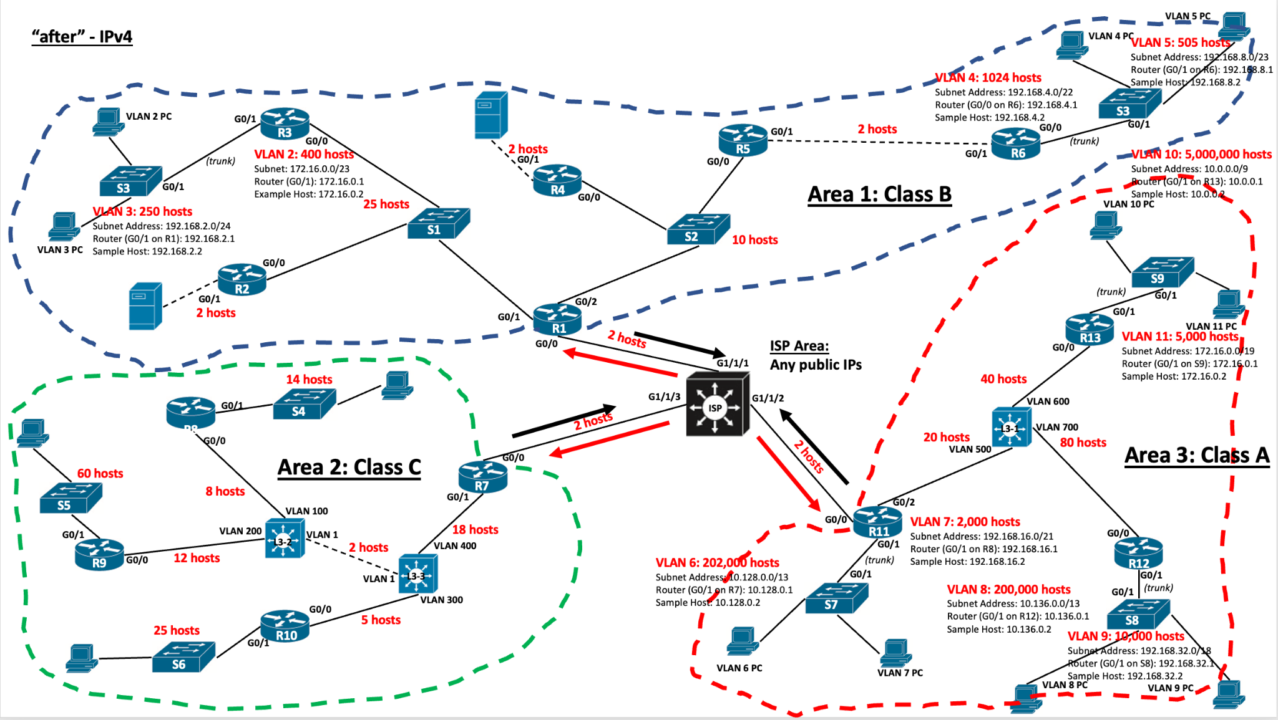

*Image 2 - the network diagram used for task 1, in an “after” state with IPv4*

## IPv6 Addressing Scheme

For IPv6, I adopted a uniform /64 subnetting for each VLAN, aligning with common IPv6 networking practices which simplify network management and allow for extensive scalability and auto-configuration capabilities - the outcome of this is seen in Image 3, further below.

### The Process

1. Uniform Subnet Allocation: Assign a /64 subnet to each VLAN, which supports an enormous number of hosts, eliminating the need for further segmentation within the VLANs.
2. Subnet Address Assignment: Use a structured approach to IPv6 subnetting, keeping hierarchical organisation in mind to ease management and future expansions.

### IPv6 Addressing Scheme Table

| **VLAN** | **Subnet Prefix** | **First Host** | **Last Host** | **Default Gateway** |
| --- | --- | --- | --- | --- |
| VLAN 2 | 2001:db8:1::/64 | 2001:db8:1::1 | 2001:db8:1::ffff:ffff:ffff | 2001:db8:1::1 |
| VLAN 3 | 2001:db8:2::/64 | 2001:db8:2::1 | 2001:db8:2::ffff:ffff:ffff | 2001:db8:2::1 |
| VLAN 4 | 2001:db8:3::/64 | 2001:db8:3::1 | 2001:db8:3::ffff:ffff:ffff | 2001:db8:3::1 |
| VLAN 5 | 2001:db8:4::/64 | 2001:db8:4::1 | 2001:db8:4::ffff:ffff:ffff | 2001:db8:4::1 |
| VLAN 10 | 2001:db8:10::/64 | 2001:db8:10::1 | 2001:db8:10::ffff:ffff:ffff | 2001:db8:10::1 |
| VLAN 11 | 2001:db8:11::/64 | 2001:db8:11::1 | 2001:db8:11::ffff:ffff:ffff | 2001:db8:11::1 |
| VLAN 6 | 2001:db8:6::/64 | 2001:db8:6::1 | 2001:db8:6::ffff:ffff:ffff | 2001:db8:6::1 |
| VLAN 7 | 2001:db8:7::/64 | 2001:db8:7::1 | 2001:db8:7::ffff:ffff:ffff | 2001:db8:7::1 |
| VLAN 8 | 2001:db8:8::/64 | 2001:db8:8::1 | 2001:db8:8::ffff:ffff:ffff | 2001:db8:8::1 |
| VLAN 9 | 2001:db8:9::/64 | 2001:db8:9::1 | 2001:db8:9::ffff:ffff:ffff | 2001:db8:9::1 |

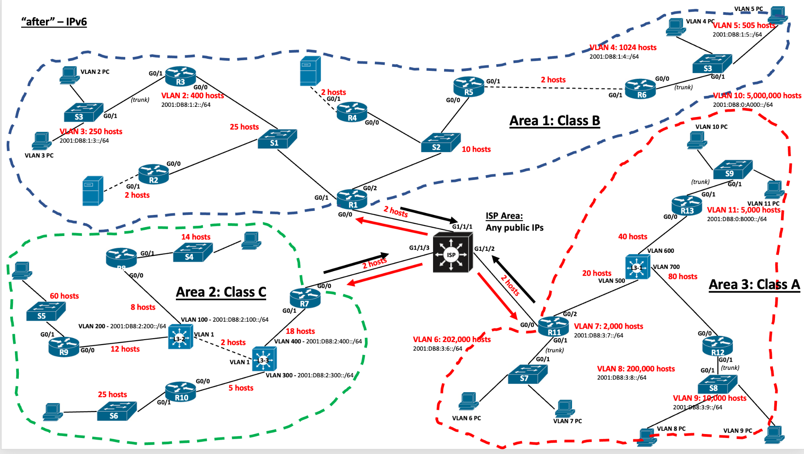

*Image 3 - the network diagram used for task 1, in an “after” state with IPv6*

## Explanation

Creating IP schemes using VLSM for IPv4 and uniform subnetting for IPv6 demonstrates a deep understanding of network addressing requirements and optimization techniques. This approach not only ensures efficient use of IP space but also prepares the network for scalable growth and simplifies management tasks. The alignment of subnetting practices with network functions and host requirements showcases a strategic approach to network design and implementation.